**Logo%20Main%20200**

**Boston University**

**Electrical & Computer Engineering**

**EC463 Senior Design Project**

First Semester Report

Submitted to

Prof. Alan Pisano

[apisano@bu.edu](mailto:apisano@bu.edu)l

by

Team 04

Brain 4ce

Team Members

Alexander Johnson [atjohnso@bu.edu](mailto:atjohnso@bu.edu)

Brendan Shortall [shortall@bu.edu](mailto:shortall@bu.edu)

Dayanna De La Torres [dayannat@bu.edu](mailto:dayannat@bu.edu)

Jonathan Mikalov [jmikalov@bu.edu](mailto:jmikalov@bu.edu)

Mitchell Gilmore [mgilm0re@bu.edu](mailto:mgilm0re@bu.edu)

Submitted: 12/11/2022

#### Table of Contents

Executive Summary ii

1.0 Introduction 1

2.0 Concept Development 2

3.0 System Description 3

4.0 First Semester Progress 4

5.0 Technical Plan 5

6.0 Budget Estimate 6

7.0 Attachments 7

7.1 Appendix 1 – Engineering Requirements 7

7.2 Appendix 2 – Gantt Chart 8

7.3 Appendix 3 – Other Appendices 9

***(right click on Table of Contents to update fields and page numbers automatically)***

# Executive Summary - Alex

EEG-based Brain-Computer Interface

Team 04 – Brain 4ce

Individuals with physical disabilities, who struggle to operate a computer, need a noninvasive, but intuitive method of interfacing with the machine without musculoskeletal movement. We propose a wearable brain-computer interface (BCI) system to resolve this problem. Our BCI will consist of a 3D printed headset housing electrodes, a sampling board to obtain electroencephalogram (EEG) data from the electrodes, a machine learning model to classify the data into directional commands, and a 3D virtual environment to demonstrate functionality. We have designed an innovative approach to combine together the classification of neuronal action potentials (APs) with a 3D computer simulation.

*(This should be written for management/public dissemination.*

*This will be published and distributed to ECE faculty.)*

# Introduction - Brendan

Since the turn of the century, brain-computer interfaces have grown in popularity. The number of publications surrounding this topic have nearly doubled since 2014 [[1].](https://www.frontiersin.org/articles/10.3389/fnsys.2021.578875/full) In many cases, invasive BCI technologies, which communicate with the brain via medical implant without interference from the scalp, have been shown to improve the lives of people with neurological illnesses [[2].](https://www.sciencedirect.com/science/article/pii/S0006349512033401?via%3Dihub) With this in mind, it is clear that the technology behind reading neural activity using medical implants has great potential.

However, invasive technologies may come with a slew of disastrous consequences for the user’s brain. A well documented complication of implanted neural electrodes are microglia immune responses. Microglial Cells release neurotoxins in response to pathological stimuli; neural implants have shown to amplify this response, causing major injury [[3].](https://www.sciencedirect.com/science/article/pii/S0165027005002931?via%3Dihub)

Invasive technologies for reading brain activity are also becoming increasingly more expensive. It is predicted that invasive BCIs will experience the fastest compound annual growth compared to non-invasive and semi-invasive techniques [[4].](https://www.grandviewresearch.com/industry-analysis/brain-computer-interfaces-market) The invasive approaches also include marginally higher expenses due to its physical implementation as well as required periodic medical check-ups [[5].](https://www.ncbi.nlm.nih.gov/pmc/articles/PMC3497935/) As a result, accessibility to invasive BCIs will become increasingly difficult for patients.

Our proposed solution avoids the dangerous risk of complications associated with electrode implants by implementing a safe and cost-effective method of non-invasive EEG pattern reading. As non-invasive EEG brain pattern recognition techniques improve, we hope to remove the risks associated with invasive techniques while maintaining and potentially improving the functionality of BCIs.

This project focuses on one of many potential applications of BCIs. In our use case, we hope to improve the usability of computer systems for physically disabled users, in a low-cost, low-risk way. To accomplish this, we will create a headset containing an array of EEG sensors positioned precisely around the user’s scalp. These sensors will be read by a mounted printed circuit board (PCB) that will communicate directly with a computer. As real time data is received on the computer, our machine learning algorithm will constantly analyze the data and make a prediction on the user’s intended movement. This prediction will be sent to our virtual environment, where a user-controlled object will move based on the user's intended action. This virtual environment acts as visual feedback for the user, so that they can adjust their behavior for the results they desire. This closed loop system will demonstrate the capabilities of non-invasive neural monitoring techniques, and will lay a foundation for future research involving non-invasive EEG based BCIs.

# Concept Development - Jonathan

Here you describe your analysis of the customer’s problem and its translation into specific engineering terms. You should address:

* your engineering understanding of the customer’s problem,
* the conceptual approach you have chosen to solve the problem, and

You must reduce the customer’s needs to a small number of engineering requirements. You must identify those requirements as a ***1-page attachment, Appendix 1***

Elaborate on the conceptual approach for your project. Explain briefly why you chose your proposed concept, and mention one or two of the alternative solutions you considered and abandoned.

***(This section should be 2-3 pages)***

***You MUST include a 1 page Requirements list as Appendix 1.***

To address the complex challenges that neurologically and physically disabled individuals face when operating a computer, our team was immediately faced with many dilemmas regarding actual implementation. First, it was made clear that the machine learning algorithm needs to communicate with both the signal processing unit and the virtual environment efficiently. Accounting for this, we considered a variety of neural network algorithms that might work optimally given our outlying data sampling techniques as well as limited CPU memory usage. These were including but not limited to: Deep Recurrent Neural Networks (DRNNs), Hidden Markov techniques, as well as the Bidirectional Long-Term Short Memory Neural Network (LSTM). After careful review of the benefits of each deep learning method, it was concluded that the LSTM model would be the best fit for our data classification model given its lack of over-reaching memory usage as well as its consistent learning ability to classify motor imagery tasks. Classifying motor imagery tasks is very important for overlying project concept as they deal directly with the backbone of an EEG-based brain computer interface. As such, we anticipate that our model needs to classify data accurately for it to be optimally used by a disabled individual.

Another core tenet behind a brain-computer interface is its ability to be worn with comfort and ease-of-access. Thus, it must not cause too much pressure to the forehead of the individual and must not be congested with wires across their desk or table. Understanding that some disabled individuals may tend to feel more sensitive pressure to the head, our team has agreed upon a thorough weight requirement of no more than 1 kilogram. This includes the headset in its entirety as well as all its connected cables to the Arduino Uno and CPU. To account for the lightweight requirement, we implemented an OpenBCI© 3D print design that allowed us to construct a headset ¼ of our weight requirement (excluding all required cables).

Our hardware requirements, which were initially relatively straightforward to design, ended up being presented with creative challenges. In one specific example, the printed circuit board’s Bluetooth module (important as it serves a direct link between the MCU and CPU), was no longer being sold in stores and had become essentially defunct. As a result, our team had to develop a new set of engineering requirements that maintained our design’s level of efficiency while also establishing an efficient method to connect a circuit board to a CPU. As a result, we developed an Arduino Uno component for the underlying architecture that will serve an important role in transferring real-time signal processing data into our CPU, to be received by the machine learning algorithm. This component of our project also needs to be optimally efficient, in such a way that it can at least process up to 500 samples of alpha & beta brainwave data per millisecond. For the detection of specific motor imagery tasks present within an EEG, our team discovered a variety of data features that can be used to relatively classify the thought being present. As a particular example, the P300 wave, which is commonly used by lie-detectors as well as other BCIs, can be seen in an EEG as a physiological pattern being produced by the thought of a particular reaction (ie. decision making).

The virtual environment component of the project, while primarily serving as a proof-of-concept for the core brain-computer interface, serves an integral role in displaying the role of BCIs used in everyday life. As such, the environment itself was designed to be graphically oriented to be appealing to a wide array of users, and present only simple features. If anything more be present, epilepsy patients or others with visual sensitivity will not be able to use this component to their advantage. An important engineering requirement regarding the use of the virtual environment is its frame rate, graphics support, and its ability to process machine learning classification in real-time. The reason of its importance mostly stems from the ability that disabled individuals need to be able to operate in a timely manner so as to not inconvenience them compared to other products on the market. As such, we discovered that the graphics library used for our 3D environment (Panda3D) not only supports an adequate framerate (usually up to 60 frames per second) but also supports a wide array of graphics cards, ranging from various versions of NVIDIA to Intel.

# System Description - Alex

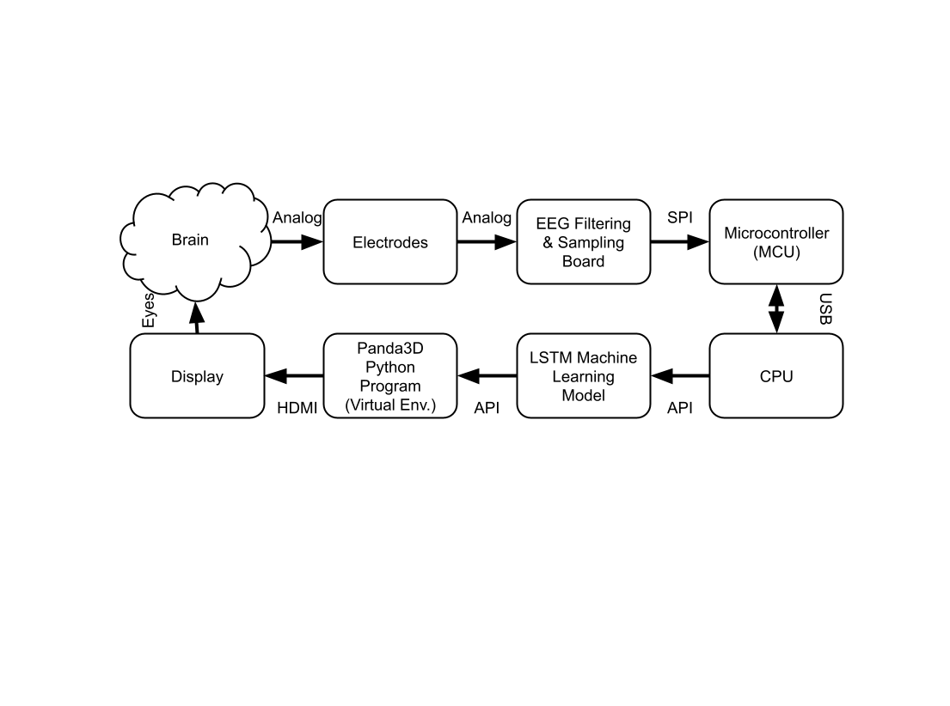

Figure 1. Block diagram of the system.

Our system begins with a set of reusable dry EEG electrodes housed in OpenBCI’s Ultracortex Mark IV headset, 3D printed using PLA material. These electrodes, located on the user’s scalp following the international 10–20 system configuration, read analog motor-imagery electrical signals in real time from the user’s brain and pass those signals along wires to OpenBCI’s Cyton PCB. Those analog signals are then filtered, digitally sampled, and passed along the PCB in 8 channels to the microcontroller. The microcontroller processes the digital signal into usable data for transmission over USB.

After the data is transmitted over USB, the computer decodes the input using the OpenBCI software suite, and it is then fed through our long-short term memory (LSTM) artificial neural network by a custom designed API. The LSTM model then classifies the data into 4 classes each representing different directions: left, right, up and down. This new dataset is interpreted by another custom API to generate the corresponding object movement in our virtual environment Python application. The final visual output of our virtual environment is displayed on a computer monitor using an HDMI connection. The user then sees this movement on the computer screen and can adjust their motor-imagery task thought patterns accordingly.

The user interface is a three-dimensional virtual environment generated in Python using Panda3D libraries. It consists of an object, tentatively a sphere, suspended on a flat surface in the environment. A set of obstacles move towards the sphere, and the user is tasked with moving the sphere out of the way before it collides with the obstacle. This game design is how our proof of concept is demonstrated.

Here you describe in technical detail WHAT YOU WILL PROVIDE as a solution. It should be as detailed, specific, quantitative, and engineering-oriented as possible.

Avoid grand promises and vague descriptions. Ruthlessly edit collective, vague adjectives and claims (e.g. “We will have high power and long life in our nuclear transmitter”). Follow the concept you are recommending from section 2.

You MUST include a system block diagram (approximately a level 2 functional decomposition) for your system/software, including a brief narrative explanation. The system block diagram should identify clearly the major subsystem blocks. Directed arrows should represent data or control flows. It is appropriate to use a full page for the system block diagram, and to import a figure developed in another application, e.g. Visio.) The following was done in Word Draw.

Figure 2. Block diagram of the Beam Transporter.

If appropriate, include a discussion of the user interface with your preliminary GUI. You can sketch the project or include a photo of your mockup.

If it is a software project, you should include high-level pseudocode of how the project will operate.

***(This section should be 2-3 pages. It is an overview description.)***

# First Semester Progress - Dayanna

**4.0.1 Hardware Progress**

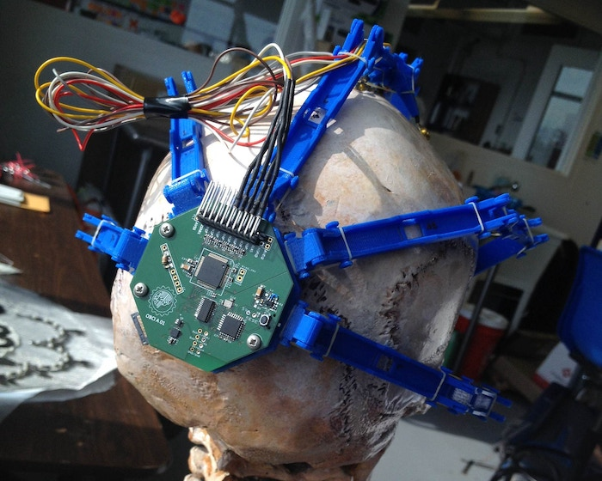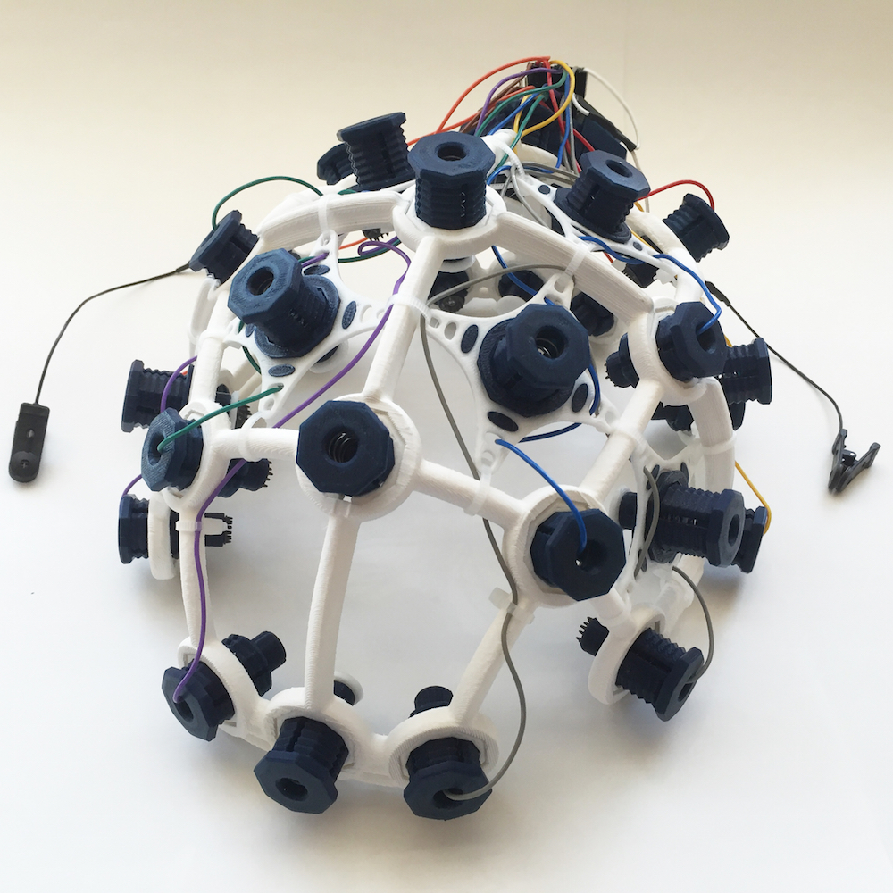

Figure 2a Figure 2b

**Figure 2: The headset Design. Figure 2a depicts the original design. Figure 2b depicts the new updated design.**

**4.0.1.1 Headset Design and Fabrication**

We based our headset on open source designs we were able to find. After 3D-printing the first iteration (figure 2a), it was promptly discarded due to structural integrity concerns. Specifically, the fact that it was held together with orthodontic elastics. We have now moved onto the second iteration of the headset (figure 2b) which we deem to be more structurally intact and solid. Moreover, it has better assigned locations for the electrodes. Together, this makes the design not only structurally better but also more comfortable for the user.

**4.0.1.2 Circuit Board Design and Fabrication**

We are modeling our circuit board after the OpenBCI sampling board. Due too the cost of the board being around $1000, we are creating it in-house. This semester we printed the PCB, ordered the necessary components, and are beginning the process of soldering said components onto the board. We have run into one component issue which is with the Bluetooth/RF module. The module used on the original OpenBCI board has been discontinued and is no longer on the market. Handling this situation and researching alternatives was a top priority for this semester in order to finish the board and begin collecting data samples.

**4.0.1.3 Collecting EEG data**

This semester we created our first prototype of the EEG system where our goal was just to receive some electrical output from the system (no emphasis on collection yet). To obtain proper readings from the EEG electrodes, we had to amplify our voltage output by 900x. To amplify the voltage output, we created a differential amplifier circuit using a set of resistors, a 5V power supply, and an MCP6002 operational amplifier. As an additional setup, electrode wires were connected to the voltage output of the circuit in order to obtain a potential physiological response from a test subject. In order to test the performance of the EEG electrodes, we attached them to multiple test subjects’ arm using conductive paste. Additionally, we detached them from the arm and placed them directly on the forehead to examine a potential change in results. Ultimately, we were unable to obtain readings from the EEG electrodes. The oscilloscope displayed a constant zero voltage regardless of the electrode placement on our test subjects. Moving forward, the electric circuit needs to be changed to address these issues.

As a side attempt to collect data, research was done into Arduino-based EEGs. While it may not be as precise, we are hoping that it will provide usable data that can then be used to train the LSTM neural network. The parts have been ordered and we have begun 3D printing the necessary components to create this smaller system.

**4.0.2 Software Progress**

**4.0.2.1 Machine Learning Model**

We have begun working on an LSTM algorithm; however, it has not yet been trained nor tested on our data due to the inability to successfully collect any to this point. The purpose of working on one thus far has been to familiarize ourselves with inputting and reformatting data into LSTMs, working with LSTM neural networks

To this date, the LSTM neural network has been trained and tested on online public databases containing EEG data. In some cases, this has failed due to a lack of understanding of the data. Machine learning algorithms are sensitive to matrix dimensions and being unfamiliar with them, and what each row/column may signify poses a problem. The NN has worked on some EEG data, namely if it is picking up readings of physical activity. This however, is different from trying to pick up thoughts which is our ultimate goal.

The most successful tests run thus far have been on physical motion. Specifically, the data that uses an accelerometer or some other type of sensor readings to measure motion/ type of motion. This has worked with over 90% success.

**4.0.2.2 Virtual Environment**

This semester we have started setting up Blender for our final virtual environment. The first task completed was running Panda3D, a game engine used to render 3D environments/games, to test for graphic issues and framerate compatibility. We did this by running sample files provided by the library and measured a variety of statistics (FPS, refresh rate, render distance) and compared them on different operating systems, specifically Windows and MacOS.

We created a draft Blender virtual environment for the initial prototyping and construction of the virtual game. This was followed up by interfacing Blender models with a Panda3D script, as this will be used to control the game in real time.

This section is a detailed summary of the progress your team has made this semester. Include key results from your First Deliverable Testing.

# Technical Plan - Mitchell

The first stage in completing our solution is EEG assembly. We have components ordered and currently in shipping but following the arrival we will have the following parallel tasks.

* Task 1: Assemble EEG PCB
  + Description:

The EEG PCB shall be assembled using already purchased components. It shall be assembled in accordance with the Schematic and Layout save for a few divergent cases documented in the logbooks. Additionally This will entail writing the provided firmware from OpenBCI to the onboard microcontroller.

* + Lead: Mitchell
  + Support: Brendan
* Task 2: Assemble EEG Headset
  + Description:

The EEG headset shall be assembled in accordance with the assembly instructions provided by OpenBCI in the [UltraCortex repository](https://github.com/OpenBCI/Ultracortex/tree/master/Mark_III_Nova).

* + Lead: Brendan
  + Support: Mitchell

Following completion of these tasks we will begin our second stage focused on data collection to train the machine learning model.

* Task 1: Collect Data from EEG
  + Description:

Data shall be collected from our prototype EEG for ML training purposes using OpenBCI GUI. The data collection process will be automated by an instructional video that will guide a user through different visualization and movement tasks to be classified.

* + Lead: Mitchell
  + Support: Brendan
* Task 2: Label EEG Data
  + Description:

Using the timing intervals of the guided video we shall assign labels to certain sections of the EEG so the ML algorithm can be trained in a supervised manner.

* + Lead: Brendan
  + Support: Mitchell
* Task 3: Forward Data to ML Lead
  + Description:

Following labeling the dataset will be released to the ML lead to begin training the ML algorithm on modality specific data.

* + Lead: Mitchell
  + Support: Brendan

After data collection we will begin the EEG redesign and ML design, train, and test phases as well as complete the virtual environment.

* Task 1: Schematic Redesign
  + Description:

The original design for the PCB is inherited from a previous open source project that is no longer maintained. In its base state it does not meet our needs, so we shall redesign it to transition from obsolete wireless communications to usb for sending data to the computer, while doubling the number of probes and removing unwanted components.

* + Lead: Mitchell
  + Support: Brendan
* Task 2: EEG Layout
  + Description:

Following the schematic redesign to include all the features we need. We shall layout a PCB in accordance with the new schematic so our new electrical system can be fabricated.

* + Lead: Mitchell
  + Support: Brendan
* Task 3: Design and Train ML Algorithm
  + Description:

Following the creation and labeling of data we shall begin work creating a LSTM Neural Network that will be trained to classify the different observable action potentials (AP) in the brain corresponding to different premotion thoughts.

* + Lead: Dayanna
  + Support: Brendan, Mitchell
* Task 4: Test ML Algorithm
  + Description:

Following training and hyperparameter tuning a partition of the dataset not yet seen by our machine learning model will be used to quantify real world performance.

* + Lead: Dayanna
  + Support: Brendan, Mitchell
* Task 5: Develop Signal Processing Scheme
  + Description:

EEG signals are inherently very noisy so as to mitigate errors associated with noise, various processing techniques will be tested in an attempt to improve classification. These methods are but not limited to cepstral analysis, parametric signal modeling, Kalman filtering as well as other to be determined relevant methods of deconvolution and reconstruction.

* + Lead: Mitchell
  + Support: Brendan, Dayanna
* Task 6: Finalize Virtual Environment
  + Description:

In order to show visually our system functioning we need a virtual environment that has an object that can be controlled with user input. Eventually this user input will be replaced by the ML predictions, but in order to finalize the virtual environment separately from the rest of the project it shall initially be configured to take in a mouse and keyboard as input.

* + Lead: Jonathan
  + Support: Alex

Following completion of the redesign phase we will need to fabricate and assemble the new EEG PCB.

* Task 1: Fabricate PCB
  + Description:

After the PCB is layed out, it will need to be fabricated. Due to the stackup of the design, we will not be capable of fabricating the PCB at BU. Therefore, the design will need to be fabricated externally through a third party vendor.

* + Lead: Mitchell
  + Support: Brendan
* Task 2: Assemble PCB
  + Description:

Following PCB fabrication the boards shall be assembled to have all its components soldered to the board to achieve full functionality and so the on board microcontroller unit (MCU) can be programmed. We will explore options for external assembly to streamline the design or assembling internal at BU.

* + Lead: Mitchell
  + Support: Brendan

After having the redesigned EEG made physically it will be time to integrate all the separately developed components into a pipelined system.

* Task 1: Interface ML Algorithm with EEG in realtime
  + Description:

With the ML Algorithm and the EEG machine tested and verified as standalone units, the two shall then be integrated together into a pipelined system.

* + Lead: Dayanna, Alex
  + Support: Brendan, Mitchell
* Task 2: Interface between ML ALgorithm and Virtual environment in real time
  + Description:

With the ML algorithm and virtual environment tested and verified as standalone units, the two shall then be integrated together into a pipelined system.

* + Lead: Dayanna, Jonathan
  + Support: Alex

Following the completion of these tasks we will have a fully functional end-to-end system to read EEG pre-motion thoughts into observable computer actions.

Describe how you plan to complete your proposed solution.

The performance period of this plan is December 11, 2012 – May 1, 2013. You should not discuss tasks that are already completed or plans that are in the past! Remember the functional testing of your project is the week of April 1 (This is when the project is “due”)

Organize this section as a discussion of tasks and milestones, integrated with your professionally prepared Gantt Chart (Appendix 2)

Tasks should be clearly named. They should be described with a verb-an action word. They should have a clear, measurable deliverable product at their completion.

*Task 2. Battery power supply*

*A 3V, 200 mA battery power supply shall be designed, fabricated and tested. It shall be rechargeable from an external connector and meet specifications for weight, battery life, and heat dissipation. The design should be tested with a dummy load of 900 ohms. Lead: Captain Kirk; Assisting: Scottie.*

***(No more than 4 pages.)***

# Budget Estimate - Brendan

Figure 3: The team’s current expenditures, and a summary of our remaining budget.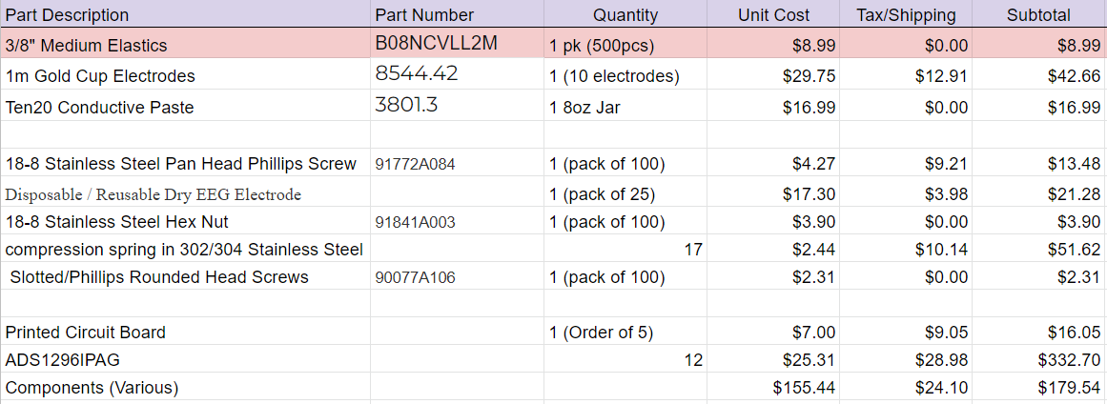

Our budget is limited to $1,000 from the Boston University ECE department. However, we have received additional funding from the Arrow Electronics Innovation Fund in the amount of $2,500. Our team plans to stay within the original $1,000 budget, but the additional funding gives us a safety cushion if need be.

With a large portion of our project being strictly software, our budget is almost exclusively used on hardware. This includes the physical headset itself, the EEG sensors, and the PCB. The first 8 items in our materials list refer to the headset. These items include electrodes, screws and bolts, springs and other various hardware needed to construct our 3D printed headset. The last three items involve the PCB and the necessary components. The part listed as “ADS1296IPAG” refers to a bio-sampling chip that will be integrated into the circuit board. The minimum quantity to order was 12. We needed only 4 or so total, but this part is essential to our project and there are no other viable alternatives. We decided buying 12 and spending the additional money is in the team’s best interest. Lastly, the item listed as various components refers to diodes, capacitors, resistors and whatever other small electronics we need for the circuit. A more detailed list of these components can be found in the appendix section 7.3.1.

In all, we have spent roughly ⅔ of our allocated budget. With that being said, essentially all of our necessary purchases have been made with no major foreseeable expenses . Financially, we are in a very comfortable position; However, we will continue to track our expenses and ensure that we remain within budget.

# Attachments

# Appendix 1 – Engineering Requirements

Team # Team Name:

Project Name:

| **Requirement** | **Value, range, tolerance, units** |
| --- | --- |
| Headset circumference | <= |
| Power | 1GJ photon source, and 3V battery |
| Transport range | >100 light years |
| Transport nodes | 3 in simplex mode (no return possible);  2 in duplex mode (round trip stored) |
| Radiation dose | 20 REM/trip +1 REM, -3 REM |
| Transport error rate | < 10-11 molecules of normal body mass  < 10-15 molecules when sending DNA data |

These are your requirements specifications that transform the customer’s needs and wants into specific engineering requirements. See the course textbook regarding the formation of appropriate specifications. Generally these are at the system integration level. Each unit that you design will have its own internal specifications, but these are usually not listed in a proposal.

Specifications should not include vague environmental constraints.

Specifications should not be statements of technology preferences or early design decisions (e.g. “The unit shall use Li ion batteries” is not a specification.)

Not more than one page.

# Appendix 2 – Gantt Chart

Here you provide a STANDARD PRESENTATION OF THE TASKS, MANAGEMENT, AND SCHEDULE of your efforts. You can access MS Project to create a professional Gantt Chart and cut and paste the chart here. (This template was done MS Project and saved to Word. Remember: Clear date headers; dependencies; milestones; hierarchical tasks; course milestones.

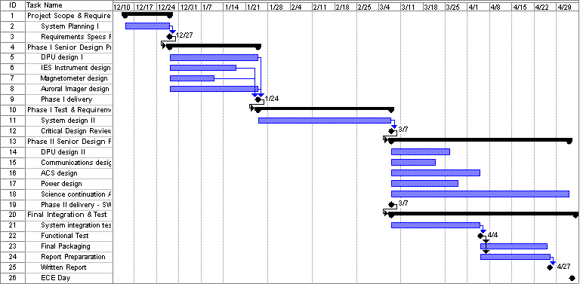

You need not include other MS Project columns like start and end dates, durations, support, etc. Make major milestones clear.

# Appendix 3 – Other Appendices

Other typical attachments that are added to bolster the competitiveness of your proposal:

* Technical references (in proper bibliographic form) including key URLs.
* Your drawings and schematics (rather than embedding in text)
* Team information sheet (Biographical paragraph on each member; phone numbers and e-mail, history of team and company)

Do not pad with mundane data sheets and application notes.

**7.3.1**

A more detailed list of the individual components listed in Figure 2.

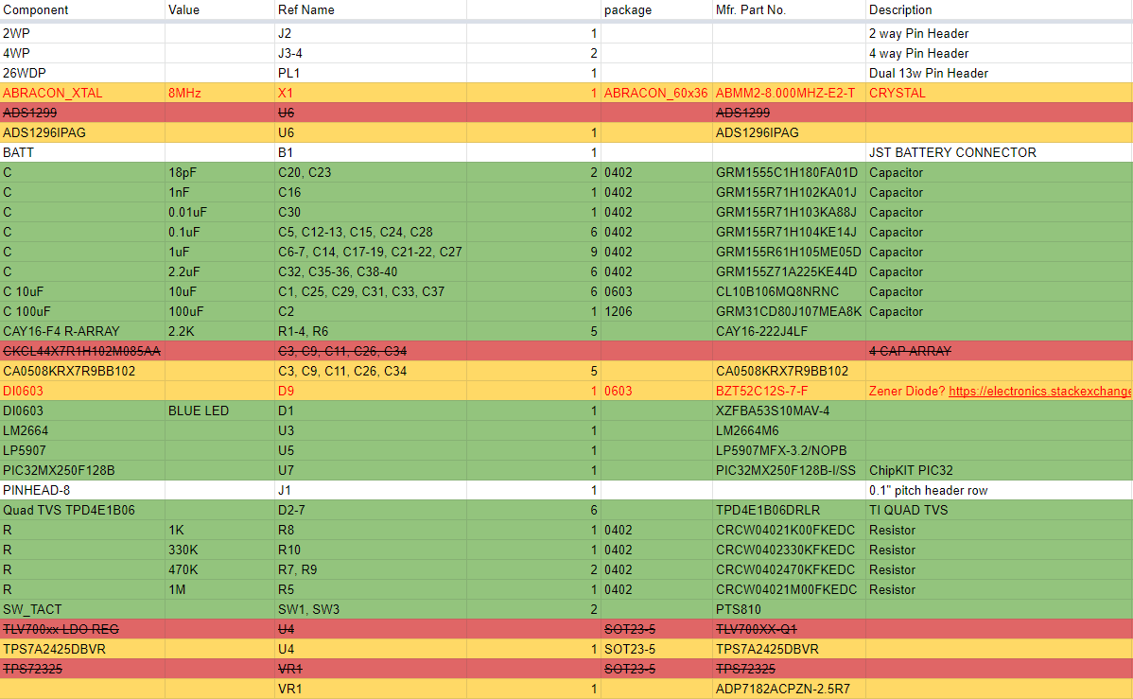

**References:**

[1] S. Saha et al., “Progress in Brain Computer Interface:

Challenges and Opportunities,” Frontiers in Systems

Neuroscience, vol. 15, Feb. 2021, doi:

10.3389/fnsys.2021.578875.

[2] L. R. Hochberg, “Intracortical Brain-Computer Interfaces for the

Restoration of Communication and Mobility,” Biophysical Journal,

vol. 104, no. 2, p. 376a, Jan. 2013, doi: 10.1016/j.bpj.2012.11.2094.

[3] V. S. Polikov, P. A. Tresco, and W. M. Reichert, “Response of

brain tissue to chronically implanted neural electrodes,” Journal of

Neuroscience Methods, vol. 148, no. 1, pp. 1–18, Oct. 2005, doi:

10.1016/j.jneumeth.2005.08.015.

[4] “Brain Computer Interface Market Size | Industry Report,

2027,” Available:www.grandviewresearch.com.

https://www.grandviewresearch.com/industry-analysis/brain-

computer-interfaces-market

[5] J. Shih, D. J. Krusienski, and J. R. Wolpaw, “Brain-

Computer Interfaces in Medicine,” Mayo Clinic Proceedings,

vol. 87, no. 3, pp. 268–279, Mar. 2012, doi:

**Spell Check Everything!!!!**

**Paginate and edit footers and headers for your team.**

**Work through at least two drafts before submitting final document.**

**DO NOT bind, put in fancy covers or otherwise embellish. Simply clip with spring binder in upper left corner.**

**Use MS Word or PDF format for final document.**

**Submit one soft copy to course via Blackboard Digital Drop Box, and one copy to customer (include cover letter to customer).**

***The body of the proposal should not exceed 20 pages.***

***(This excludes the cover page, table of contents, executive summary, and attachments.)***